Iteration 1 Models
Use Cases:

UC-01 | Player Starts The Game
Description | Player starts the application for the first time and gets ready to play the game
Actors | One application, one to many individual players waiting to play
Starting Condition | N/A
Main Sequence | - User starts the game application  - System responds with an opening screen, waiting for user input  - User selects to start a new game from the menu provided  - System builds the player listing, board, and player movement options  - User enters player information by clicking on available add button, specifies both the name and class they which to play as  - Step 5 is repeated until the desired amount of players has been meant  - User starts game
Post-Condition | Game has started and players begin taking their desired turns

UC-02 | Player Attempting To Move To New Clearing
Description | After game is running, player attempts to move along the board
Actors | Current player for the turn
Starting Condition | UC-01 must be meant before this can be carried out
Main Sequence | - Current player of the game selects the move option from the available list  - System responds by highlighting all available clearings that connected to there player's connected clearings  Repeatedly:  - Player selects a valid area for the character movement  - System checks the area to see if is a valid move for the player  - System records “M-” followed by the clearing name to the player's log  - System moves player to new area, highlighting new connected clearings for the next movement
Post-Condition | Player has moved their current clearing to the new clearing
Alternative Scenarios | - The player might at any point select to cancel the movement action by selecting another action from the ones provided  - Player may not actually move from their current clearing as they can move back and forth in between tiles

UC-03 | Player Attempts To Hide In Current Clearing
Description | During the current player's turn they attempt to hide for their turn
Actors | Current player for the turn
Starting Condition | UC-01 must be meant before this can be carried out
Main Sequence | - User starts their turn and is unhidden if the are currently hidden  - User selects hide from the available list of commands available  - System generates value to determine if player becomes hidden  - If player becomes hidden, their tile becomes green until they become unhidden from another means  - If player stays unhidden then their tile will remain the same
Post-Condition | Player has been hidden based on the result from the system

UC-04 | Treasure Searching And Looting
Description | During the player's turn they search and/or loot the current clearing they are in
Actors | Current player for the turn
Starting Condition | UC-01 must be met before this can be carried out
Main Sequence | - User starts their turn  - User selects the search option from the list of commands  - System responds with dialogue with available options for searching  - User selects to either search or loot from the clearing  - If user selects to search clearing, system searches the player's clearing, giving the player access to the hidden items if they are found  - If user selects loot, the player loots the available treasure and adds it to their current collection
Post-Condition | Player has searched the area and may have new treasures added to their inventory

UC-05 | Displaying Detailed Character Sheet
Description | Steps for displaying the character sheet for the selected player
Actors | One or more players currently playing the game
Starting Condition | Application must be ran but the game does not need to have been started.
Main Sequence | - User selects a player from the list  - User clicks on the option to show detailed card  - System responds by displaying the character detail sheet for the selected player's class
Post-Condition | Player detail has been displayed

UC-06 | Player Enters Combat With Another Player
Description | Steps for conducting combat between a player and another player
Actors | More than one player currently playing the game
Starting Condition | UC-01 must be met before this can be carried out and multiple players must be unhidden on the same clearing
Main Sequence | - All players have sent their turn and two players are unhidden on the same clearing  - A combat user interface is opened for the players  - The luring phase of combat is initiated  - Users select which enemies they would like the lure by pressing the enemy buttons in the combat user interface  - The charging phase of combat is initiated  -  - The manoeuvres and attack phase of combat is initiated  - Users select whether or not they would like to thrust, swing, or smash for their attack  - Users select whether or not they would like to dodge, duck, or charge for their manoeuvre  - Attacking phase is resolved  - Harm is calculated and applied to users  - Fatigue is calculated and applied to users  - Steps 3 through 6 are repeated until there is no more than one player in a clearing or nothing happens for 2 rounds
Post-Condition | Combat has been resolved

Unbounded Use Case Maps:
UC - 01
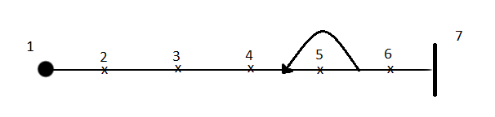

Tag | Responsibility
1 | User starts the game application
2 | System responds with an opening screen, waiting for user input
3 | User selects to start a new game from the menu provided
4 | System builds the player listing, board, and player movement options
5 | User enters player information by clicking on available add button, specifies bith the name and class they which to play as
6 | User starts the game
7 | The game has started

UC – 02

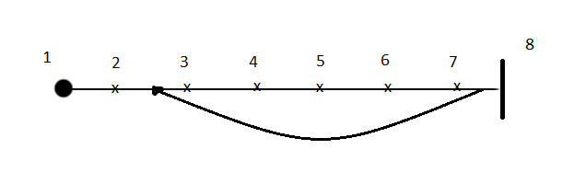

Tag | Responsibility
1 | Current player of the game selects the move option from the available list
2 | System responds by highlighting all available clearings that connected to player's connected clearings
3 | Player selects a valid area for the character movement
4 | System checks the area to see if it is available for the player to move to
5 | System records “M-” followed by the clearing name to the player's log
6 | System moves player to new area
7 | System highlights clearings connected to new area
8 | Player has finished moving to the desired clearing

UC-03
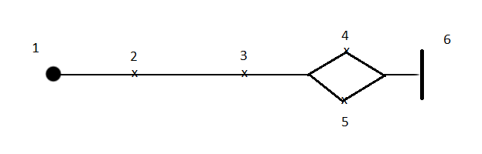

Tag | Responsibility
1 | User start their turn and is unhidden if they are currently hidden
2 | User selects hide from the available list of commands
3 | System generates value to determine if player becomes hidden
4 | Player becomes hidden, their tile becomes green until they become unhidden
5 | Player stays unhidden (hiding failed)
6 | The player has attempted to become hidden

UC-04

Tag | Responsibility
1 | User starts their turn
2 | User selects the search option from the list of commands
3 | System responds with a dialogue that contains options for searching
4 | User has selected to search clearing, system searching the clearing and gives the player access to hidden items if found
5 | User selects loot, the player loots the available treasure and adds it to their inventory
6 | The player has searched or looted their clearing

UC-05
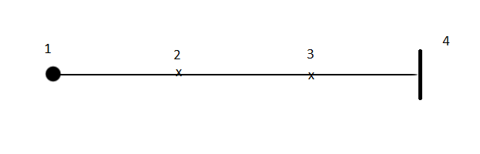
Tag | Responsibility
1 | User selects a player from the list
2 | User clicks on the option to show detailed card
3 | System responds by displaying the character detail sheet for the selected player's class
4 | Player detail has been displayed

UC-06
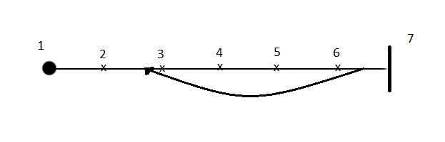
Tag | Responsibility
1 | All players have sent their turn and two players are unhidden on the same clearing
2 | A combat user interface is opened for the players
3 | The luring phase of combat is initiated, users select the enemies they want to lure
4 | The charging phase of combat is initiated
5 | Players select which maneuver they would like to use and which attack they would like to use
6 | Attacking phase is resolved, harm and fatigue is calculated and applied
7 | No more than one player is on the clearing or nothing has happened for 2 rounds, combat is resolved

